Implications of the Post Covid Crisis on Psychological Safety of the Doctors
Ms. E. Lisa¹

Abstract:
World is facing an unexpected crisis from the year 2019 and the human kind is fighting against invisible enemy called Corona Virus. People infected with this virus fight a war between life and death in getting cured and many have not succeeded in that war. This crisis has left everyone clueless in handling this tough situation, the ones on the frontline: doctors, nurses, health care workers are working excruciatingly day and night to help people come out the infection and to save their lives. There were doctors who selflessly work sacrificing their time, food, health and lives. Since there is lack of cure for this deadly infection the doctors were left clueless in their work which gave them extra work, effort and sacrifice in handling the situation, this further leads in giving them a pressure by being far from their loved ones. Universe of this study was young doctors (doctors who have less than five years of experience) handling covid patients. A sample of 85 respondents was taken with snowball sampling technique. Tool used was Anxiety and Perceived Stress Scale by Sheldon Cohen and Depression Anxiety Stress Scale-21 by Lovibond S.H & Lovibond P.F, Reliability of the tool was reestablished using Cronbach’s Alpha reliability test which was .832. Collected data was analyzed using SPSS version21. It was found the doctors were obviously undergoing stress and faced lot of challenges during both the waves of corona but addressing their challenges or mental agony was left behind.
Keywords: Young Doctors; COVID Duty; Challenges; Stress

Introduction:
The CORONA Virus infection started from Wuhan, China in 2019 and spread all over the world. The rapid spread of the infection took its worse situation even in India and more and more people got admitted in the hospital to get themselves cured. It brought in a pressure among the Doctors and other medical professionals. They risk their lives in saving many of the lives. Since it is an unexpected crisis which doesn’t have proper medicine for this infection the medical professionals were initially clueless in handling the situation. This brought in anxiety, depression, stress, pain and deaths among the medical professionals. This virus infection has brought in drastic change among the lives and lifestyle of human being. Being a deadly disease this infection has left lot of lesson to the human kind to think and react. In India still the country is facing the crisis and in that the doctors who are in frontline to take care of the patients are being mentally and psychology affected. There were several reports and cases which reported the violence against doctors during covid duty.
As per Government of India, death of doctors during the COVID crisis till Novemebr 2020 was 162, but the Indian Medical Association report says that 734 doctors died during the COVID duty as per their report on February 2021 and among them twenty five percent of doctors were below 35 years of age. Response to this comment by Ministry of Health and Family Welfare in Rajya Sabha was 162 doctors, 107 nurses and 44 AASHA workers have died during covid 19 duty according to Pradhan Mantri Garib Kalyan Package: Insurance Scheme. Dr. Jayalal, Chief of Indian Medical Association posted his comment on the report submitted by the Government was that the Government has the data of who have been covered under particular insurance scheme but the report submitted by the association was ignored by the government.

¹Assistant Professor and Head, P.G. & Research Department of Social Work, Sacred Heart College (Autonomous), Tirupattur. Mail Id: lisaelango@gmail.com
He further mentioned government has also failed to address the issues and psychological challenges faced by front line workers in specific the doctors, many doctors have gone under depression and stress which has affected their physical and mental health. (Sirur Simrin, 2021).

Review of Literature:
Sukhendu Dey & et al., (March 2021), in their study, “COVID 19 and its consequences among medical workers”, carried out research among the medical workers from 36 states and union territories. It was clear from their study that the doctors, nurses, and other front line workers in the medical field have faced stress during and after their COVID duty in both the first and second wave. WHO has recommended the each government to safe guard the mental health of the medical workers since it is important that government takes care of this selfless people who were one among the others those who helped in taking care of COVID patients. But in country like India it is a big challenge. This study reports that 93.8% of this study said COVID 19 pandemic greatly impacted their daily life like transportation problem, high risk of infection, panic against infecting family, assault, and health problems. It was reported that respondents expected government to implement psychological crisis intervention, much intervention on vulnerable group, more strengthened and improved health service systems, nationwide strategic management planning followed by telemedicine services.

Saroni Biswas & Arijit Bhowmik (August 2020), in their research “Psychological Impact of Medical Professionals handling COVID 19 patients in Hospitals”, studied the doctors handling COVID patients using three standardized tools namely Generalized Anxiety Disorder, Depression Anxiety Stress Scale and Hospital Anxiety Depression Scale. It was reported that doctors faced depression and stress resulting in mental and physical health problems. It was also highlighted that the professionals between the age group of 30 to 40 years being young professionals were facing anxiety and depression more than the experienced professionals. This was reported because of the long working hours, lack of family contact, and panic towards the pandemic and unexpected health issues of patients. Study has brought out that wearing the PPE kit for the whole day resulted in anxiety and stress because of the suffocation which they undergo while wearing it. Doctors being one among the life saving professionals it should be made sure by the government that safeguarding their mental and physical health should be addressed on time.

Working Definition:
Young Doctors: Young Doctors are defined as the medical professionals who have been qualified under Indian Medical Council Act 1956 with less than five years of working experience.

Research Methodology:
The study was carried out among the young doctors who have less than five years of experience in their field. Researchers adopted Descriptive Research Design for this study. To find the anxiety and Perceived Stress Scale by Sheldon Cohen, 1988 and Depression Anxiety Stress Scale-21 by Lovibond S.H & Lovibond P.F, 1995 was used and Reliability of the tool was reestablished using Cronbach’s Alpha reliability test which was .832. This tool was circulated among the doctors who are working in hospitals handling the COVID patients both in the first and second wave. The sampling technique used for this study was Snow Ball Sampling technique and data was collected was analyzed using SPSS version 21. Analyzed data were presented in the form of tables and interpretations were done by running different tests like, frequency test, correlation and chi square test.

Aim:
To study the challenges faced and stress level of young doctors during their duty in handling COVID patients.
Objectives:
- To bring out the challenges faced by doctors during COVID duty.
- To study the stress, anxiety and depression level of doctors.
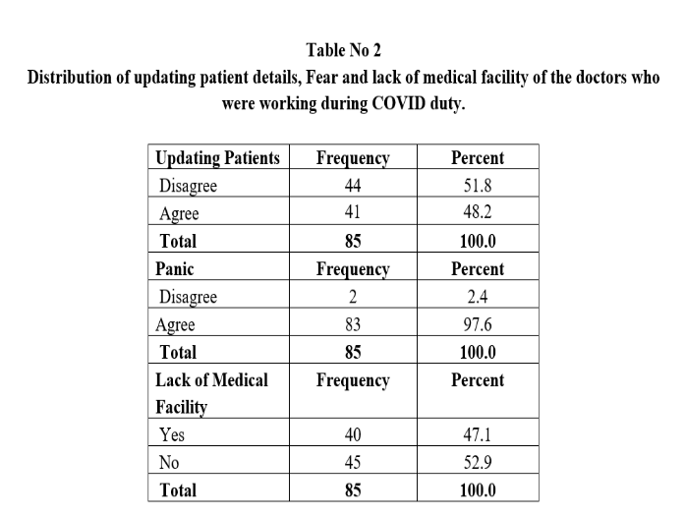
- To understand the implications on psychological safety of doctors.
- To highlight the suggestions given by the doctors.
Findings:
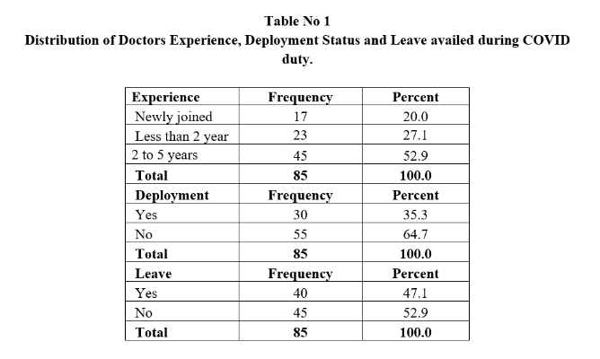
The study findings are listed out below along with the analysis and interpretation.

The Table No 1 illustrates the experience in the field as doctors, whether the doctors were deployed from their hospital to other hospital for handling the patients during crisis and whether they were able to avail leave for any emergency during their duty in the crisis situation. The Researchers carried out this study only with the doctors who were new to this profession or who have less than five years of experience. Thus it was evident that all the respondents were within five years of experience practicing as doctors.
So it can be inferred that since it was a pandemic situation and sudden crisis which left everyone under fear, the practioners were allowed to avail leave only if it was an unavoidable situation or else mostly their leave was denied even if it was an emergency situation for them.
Since it was a sudden crisis and required the need of many health care professionals rather than the usual number, many doctors were deployed from their place of practice to other hospitals to handle the patients affected by COVID. This was also the major reason for the doctors to get into stress initially during the first and second wave of the pandemic situation.

Table No 2 demonstrates that doctors were able to update the relatives and patients about their conditions and situations though they were completely engaged with treating patients.
Explaining the diagnosis and treatment process to the patients or their relatives will keep the person updated and will be aware of what is the status of their illness. So, it was achieved by half (51.8%) of the doctors but a little less than half (48.2%) of the respondents said they were unable to update the patients’ relatives about the patient’s condition for which they felt very bad and helpless.
This table describes that almost all (97.6%) the respondents said they worked with the COVID patients only with complete fear of being infected and also with the fear of saving the patient’s life, since many who were healthy and stable also lost their life suddenly due to this infection. This fear and panic was filled in within the doctors and other frontline workers rather they helped in saving many lives doing their duty with full consciousness.
There was a mixed response from the respondents saying that during the COVID duty they were able to get all the medicines and medical facilities to handle the patients rather the other group of respondents said they didn’t get all the medical facilities to treat their patients because of which they were not able to treat the infected patients on time.

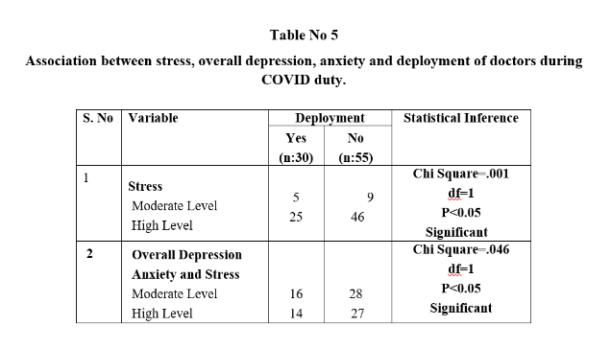
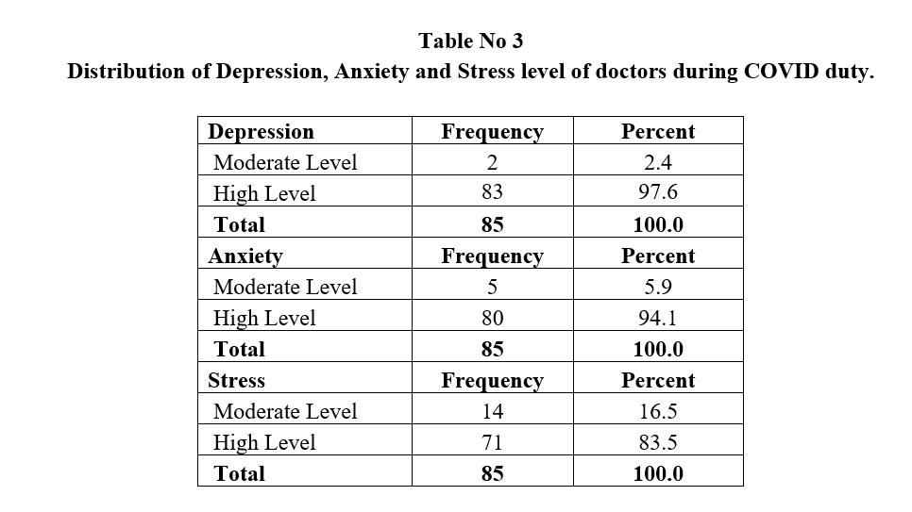
The researchers used the Depression, Anxiety and Stress Scale with 21 items to test the level of the doctor’s depression, anxiety and stress felt during COVID duty. The table 3 depicts the score of depression, anxiety and stress each. It was understood that doctors mostly went into depression and stress since they were facing a situation of life and death. The time of COVID crisis brought in a fear of saving their life and their family life against this infection which is a deadly disease. Handling the patients, treating them, being safe from infection, preventing their family from infection, being far from the family, continuous duty without time to rest brought in doctors to a state of depression and stress.
Most of the doctors were also anxious about their health and their family’s health during the pandemic situation. This anxiety was developed because of lack of contact with their family and by the fear of them to be a carrier of infection to their families. Unexpected situations and patient illness made them anxious and it resulted in unwanted psychological pressure among them.

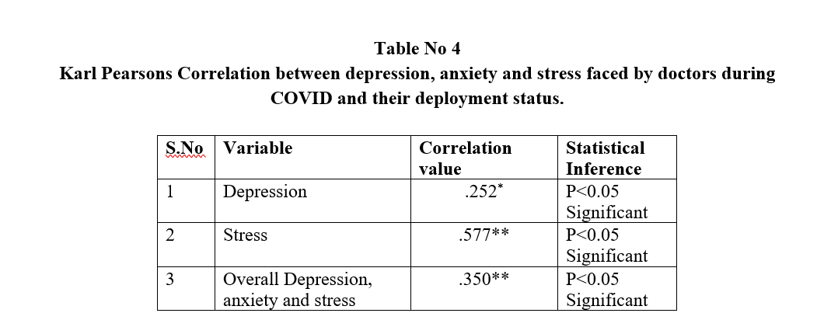
From the table no 4 it was evident that since the respondents were deployed from their place of practice initially the doctors found it difficult to adopt and adjust with the hospital facilities and other front-line workers. This resulted in depression, anxiety and stress for most of the doctors. The stated result was identified by the Significance value, since the level of significance was lesser than 0.05 it was clear that there was relationship between deploying the doctors to a new place of practice during COVID and they being affected with depression, anxiety and stress.

The presented table 5 illustrates that there is significant association between the stress and deployment of doctors from one place to another place during COVID. It can be inferred that already doctors were in complete crisis during the COVID situation and they were feeling the anxiety and stress in high level when they are were deployed from their practice place to other hospitals.
Discussion and Conclusion:
This study among the doctors who worked during the crisis in the year 2020 and 2021 brought out the struggle and stress which they felt during their duty. Being in their initial phase of practice as professional doctors they had an opportunity to work with patients who were infected by a new type of virus (COVID 19). This was a usual situation for even an experienced doctor. In that sudden crisis the whole world was clueless and options less when dealing with this pandemic situation. Among everyone it was the frontline workers who sacrificed their lives to help people to overcome this crisis. When we discuss about frontline workers in this study we have taken only doctors with less than five years of experience to bring out the stress and anxiety which they had while treating the patients and the researchers have also highlighted the suggestions given by doctors.
It was evident that doctors were anxious dealing with patients and the situation, further this brought in stress among the doctors. Study finding highlights that rather being new to this profession and with less years of experience they were able to handle the situation professionally. Doctors were able to avail leave if there was any emergency and this was said by half of the respondents who participated in this study. This helped them to make sure that they visit their family and spend time with their loved ones addressing their needs. This research also highlights that doctors always had a panic within themselves that they should not be the carriers of infection to their family.
When it comes to stress, anxiety and depression because of this covid situation, it was clear that almost all the respondents faced it during this crisis. The main reason for their stress, anxiety and depression are highlighted by the researchers as it was expressed by the respondents.
- “Violence towards the doctors: especially in India. I personally experienced from one of my patient’s attender. About 650 doctors in India lost their lives during this may month because of this covid. Around 1300 Doctors lost their lives in India during this whole pandemic. Even in this situation, we are serving the patients and facing the violence from patients and their relative’s side. Doctors, nurses and healthcare workers are giving their lives to fight this pandemic. We don’t want them to treat us like a GOD. We just expect them to treat us like HUMAN.
- Facing a pandemic that too at start of my carrier is an experience for lifetime. Covid duty drained me both physically and emotionally.
- Sometimes being helpless when two or more patients collapse at the same time.
- As an intern I had to do both covid and non-covid duty on the same day. We were not given quarantine too. Due to shortage of bed availability patient attenders would become aggressive when we inform them which would make us feel insecure. With our lives risking and not seeing our family members for a long time we work for the welfare of others but it hurts to see people attacking doctors.
- Found some difficulties in treating patients on how to convince them about their condition. Be it serious or mild cases.
- I felt bit stressed about handling patients and exposing my family to the condition
- Whenever my family members got infected I am getting more scarred
- I have a 3 months old baby. I actually fear if I would transfer it to her. I used to think like this What if I am asymptomatic and transfer it to her unknowingly. Shall I wear mask all the time even at home complete 24 hrs of wearing mask. I used to think much and get panic. This created a kind of stress
- Handling more than 50 patients sometimes including ICU without the help of staff nurse and little help from seniors is exhausting.”

The expectation and request from the doctors was to the Government and the public to understand their pain and sacrifice. They highlighted that incentive or promotion will not reduce our stress and anxiousness but all their sacrifice was made worth when a covid patient gets well and discharged. The researchers would like to conclude this study by highlighting the suggestions from the researchers and the respondents, if there are any such crisis in future then the following points should be considered: to give them some rest during such duty by appointing a greater number of health care workers, when there is assault or attack from the public, government should stand by their side to protect and some minimum time with their family, Ordinance declared by the government can be further extended, tele counselling, tele medicines for mild infections, proper communication channel between patients and their family member, Sensible role of media, Self defense techniques can be taught to the front line workers, and better primary health care facilities. Though there were false reports, loss of lives, lack of support from government and public, the work and sacrifice of all the frontline workers can never be forgotten and they still be appreciated, supported and worshipped for their self-less service, by many hearts in this world.

Works Cited and Reference:
- Anirban Biswas, Saroni Biswas, Arijith Bhowmik. (2020). Psychological Impact of Medical Professionals Handling COVID Patients in Hospitals. Journal of Toxicology and Risk Assessment. 6 (1), 1-8. Retrieved From: file:///C:/Users/welcome/Downloads/international-journal-of-toxicology-and-risk-assessment-ijtra-6-034.pdf
- Lisa. E. (2017). Stress Coping Behaviors. Journal of Social Science and Management Research. Sacred Heart College Journal Publications. Thirupattur. 26- 30.
- Mamidipalli Sai Spoorthy, Sree Karthik, Pratapa, Supriya Mahanth. (2020). Mental health problems faced by healthcare workers due to the COVID-19 pandemic–A review. Elsevier Public Health Emergency Collection. Retrieved From: https://www.ncbi.nlm.nih.gov/pmc/articles/PMC7175897/
- Shaukat Natasha Natasha Shaukat, Daniyal Mansoor Ali, Junaid Razzak. 2020. Physical and mental health impacts of COVID-19 on healthcare workers: a scoping review. International JournalofEmergencyMedicine.Article40. Retrieved From: https://intjem.biomedcentral.com/articles/10.1186/s12245-020-00299-5
- Sirur Simrin. 2021. Govt says 162 doctors on Covid duty care have died, ‘shocked’ IMA pegs number at 734. The Print Blog. Retrieved From: https://theprint.in/india/govt-says-162-doctors-on-covid-duty-have-died-shocked-ima-pegs-number-at-734/598059/
- Sukhendu Dey, Sandipan Pal, Apurba Ratan Ghosh, Palas Samanta. (2021). COVID 19 and its Consequences among Medical Workers. JSM Environmental Science and Ecology. Retrieved From: file:///C:/Users/welcome/Desktop/COVID-19andItsConsequences-9-1073.pdf
- World Health Organization. (2017). Mental Health ATLAS.
- Jebaseelan, U.S., & Fonceca, C.M. (2016). Recent Trends in Research: An Interdisciplinary Approach. Bishop Heber College. Trichy.

